Analysis of Airline Ticket Pricing

NAME: James Rohan Gangavarapu

EMAIL: james.reckon@gmail.com

COLLEGE / COMPANY: Georgia State Univiersity

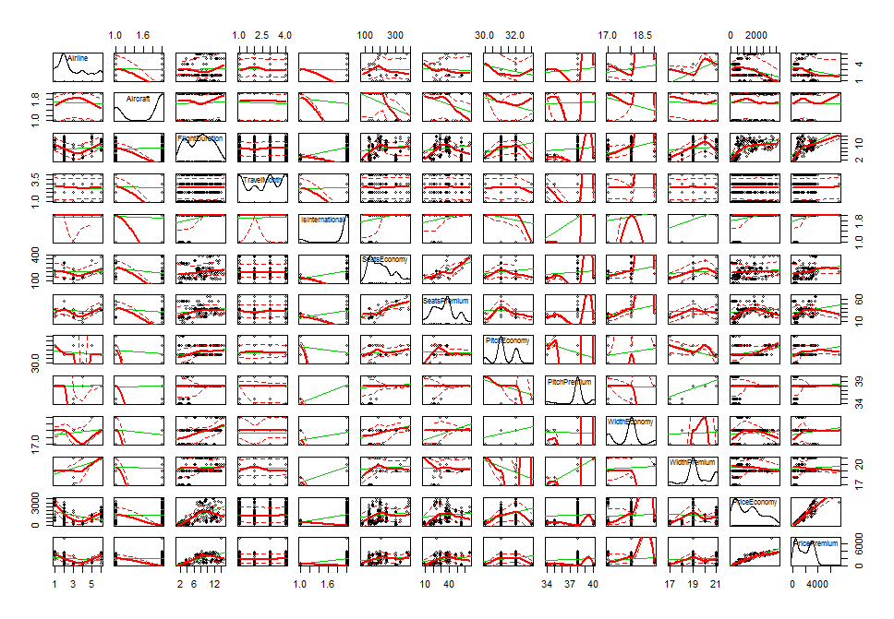Scatter Plot Matrix:

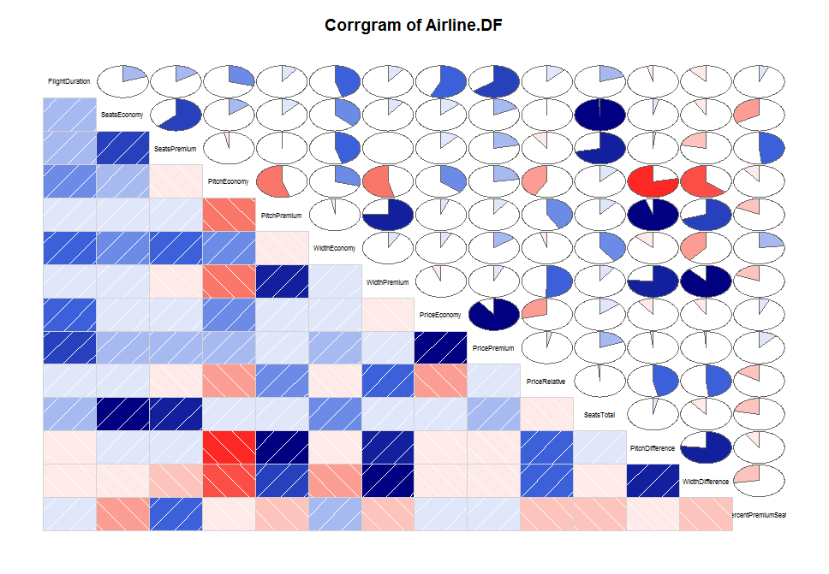Corrgram:

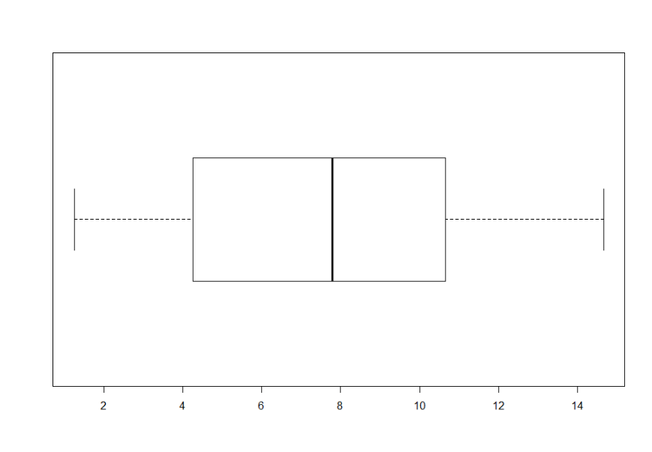Box Plots:

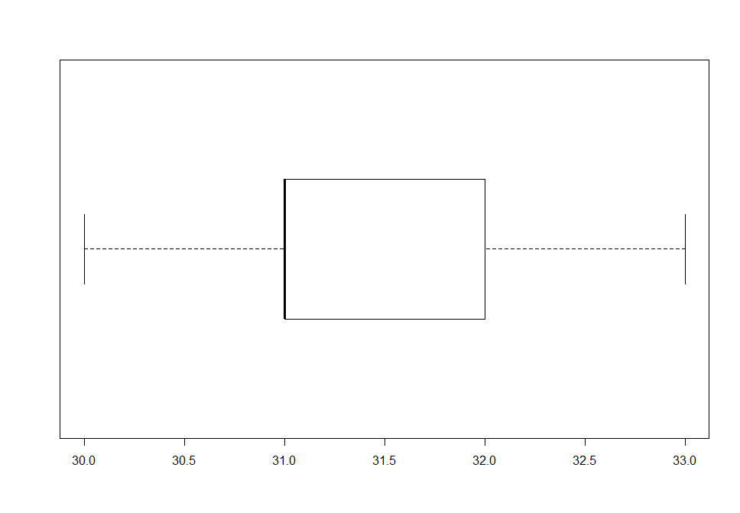

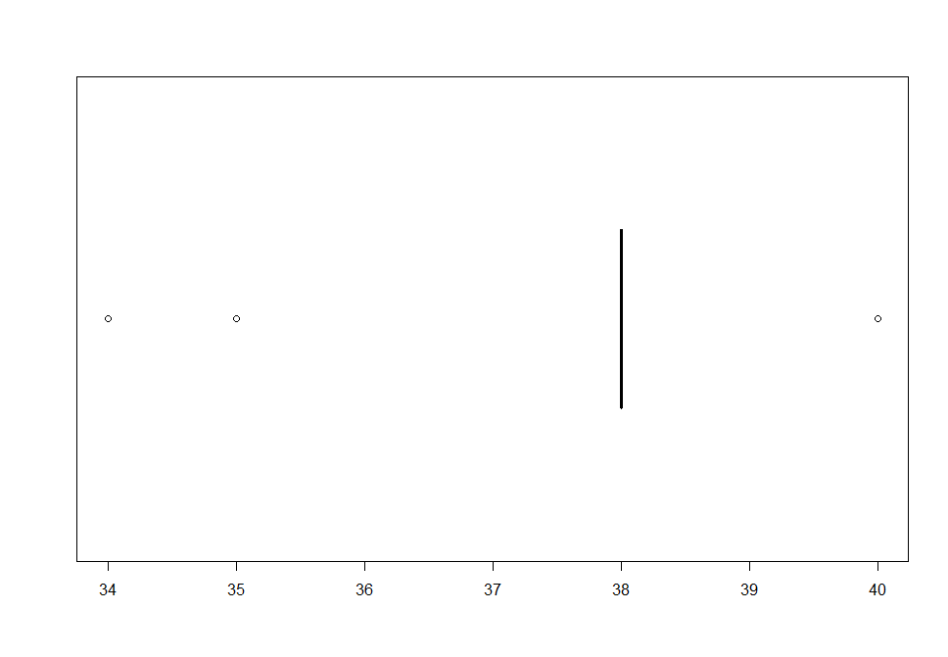

Hypothesis 1 :

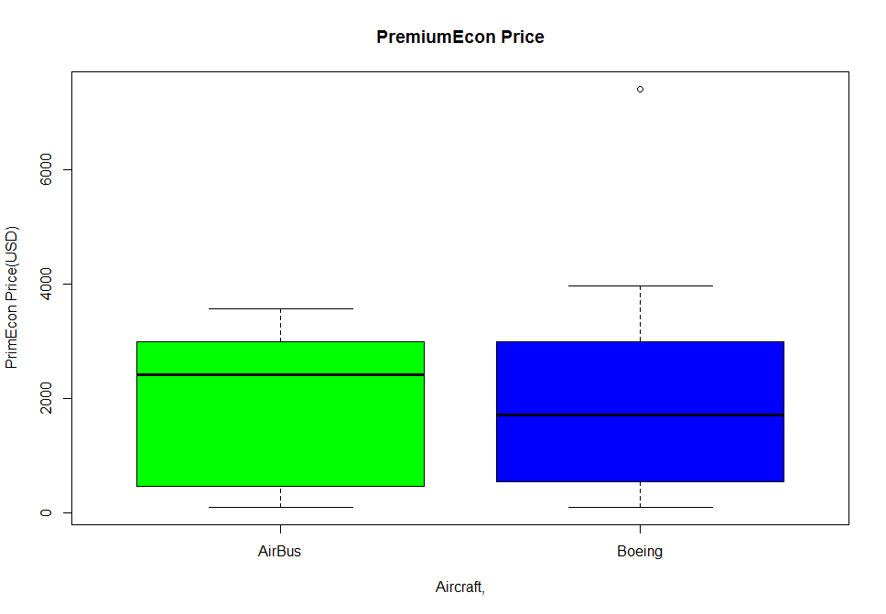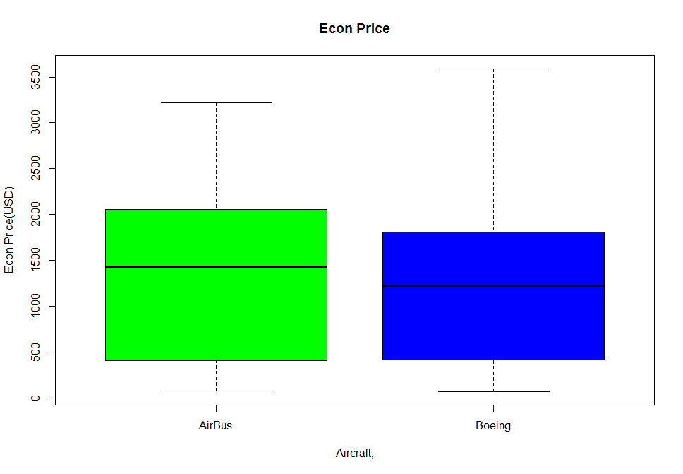

> t.test(Airline.df$PricePremium~Airline.df$Aircraft)

Welch Two Sample t-test

data: Airline.df$PricePremium by Airline.df$Aircraft

t = 0.28645, df = 310.38, p-value = 0.7747

alternative hypothesis: true difference in means is not equal to 0

95 percent confidence interval:

-212.2929 284.6350

sample estimates:

mean in group AirBus mean in group Boeing

1869.503 1833.332

> t.test(Airline.df$PriceEconomy~Airline.df$Aircraft)

Welch Two Sample t-test

data: Airline.df$PriceEconomy by Airline.df$Aircraft

t = 0.64317, df = 289.45, p-value = 0.5206

alternative hypothesis: true difference in means is not equal to 0

95 percent confidence interval:

-131.7801 259.7135

sample estimates:

mean in group AirBus mean in group Boeing

1369.954 1305.987

Hypothesis 2:

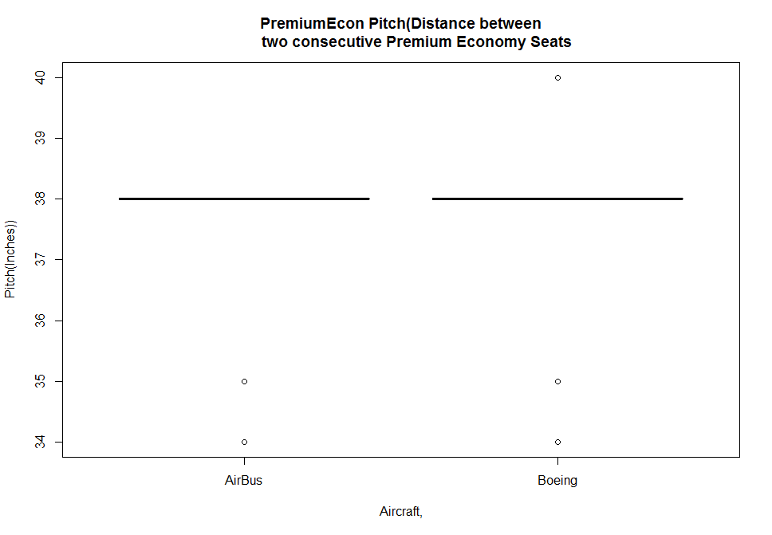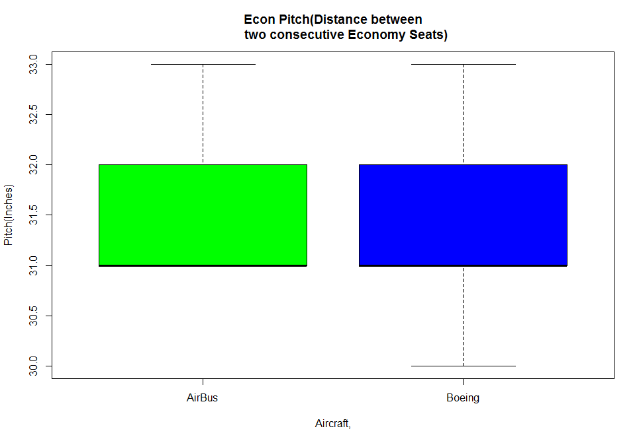

|  |
| --- |
| > t.test(Airline.df$PitchPremium~Airline.df$Aircraft)  Welch Two Sample t-test  data: Airline.df$PitchPremium by Airline.df$Aircraft  t = -0.82168, df = 455.91, p-value = 0.4117  alternative hypothesis: true difference in means is not equal to 0  95 percent confidence interval:  -0.2956547 0.1213121  sample estimates:  mean in group AirBus mean in group Boeing  37.84768 37.93485  > t.test(Airline.df$PitchEconomy~Airline.df$Aircraft)  Welch Two Sample t-test  data: Airline.df$PitchEconomy by Airline.df$Aircraft  t = 5.6936, df = 387.69, p-value = 2.46e-08  alternative hypothesis: true difference in means is not equal to 0  95 percent confidence interval:  0.2136461 0.4390278  sample estimates:  mean in group AirBus mean in group Boeing  31.43709 31.11075 |
|  |
| |  | | --- | | > | |

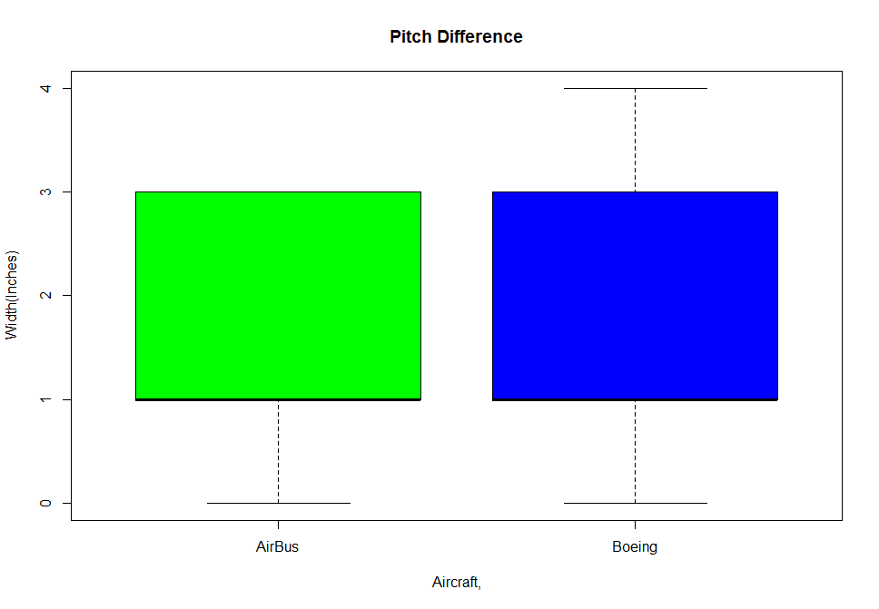

> t.test(Airline.df$WidthPremium~Airline.df$Aircraft)

Welch Two Sample t-test

data: Airline.df$WidthPremium by Airline.df$Aircraft

t = 1.0198, df = 334.28, p-value = 0.3086

alternative hypothesis: true difference in means is not equal to 0

95 percent confidence interval:

-0.09898334 0.31211189

sample estimates:

mean in group AirBus mean in group Boeing

19.54305 19.43648

> t.test(Airline.df$WidthEconomy~Airline.df$Aircraft)

Welch Two Sample t-test

data: Airline.df$WidthEconomy by Airline.df$Aircraft

t = 7.4115, df = 428.46, p-value = 6.722e-13

alternative hypothesis: true difference in means is not equal to 0

95 percent confidence interval:

0.2497153 0.4299663

sample estimates:

mean in group AirBus mean in group Boeing

18.06623 17.72638

> t.test(Airline.df$WidthDifference~Airline.df$Aircraft)

Welch Two Sample t-test

data: Airline.df$WidthDifference by Airline.df$Aircraft

t = -2.2142, df = 398.27, p-value = 0.02738

alternative hypothesis: true difference in means is not equal to 0

95 percent confidence interval:

-0.4403966 -0.0261565

sample estimates:

mean in group AirBus mean in group Boeing

1.476821 1.710098

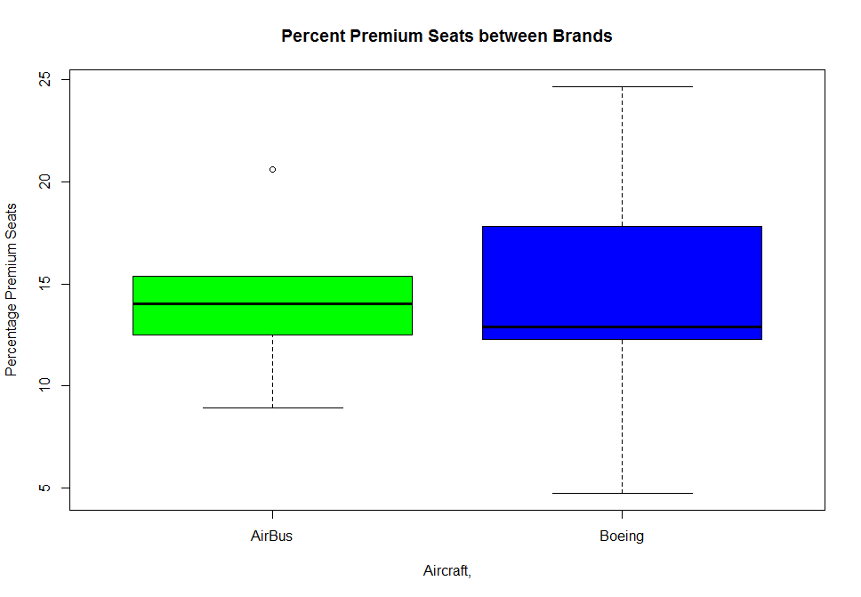

|  |
| --- |
| > t.test(Airline.df$PercentPremiumSeats~Airline.df$Aircraft)  Welch Two Sample t-test  data: Airline.df$PercentPremiumSeats by Airline.df$Aircraft  t = -3.0711, df = 455.55, p-value = 0.00226  alternative hypothesis: true difference in means is not equal to 0  95 percent confidence interval:  -1.9650970 -0.4315093  sample estimates:  mean in group AirBus mean in group Boeing  13.84219 15.04049 |
|  |
| |  | | --- | | > | |

|  |
| --- |
| > summary(LinMod_Boeing_PremEconPrice)  Call:  lm(formula = PriceEconomy ~ PitchPremium + PitchEconomy + WidthPremium +  WidthEconomy + WidthDifference + PercentPremiumSeats, data = Boeing.df)  Residuals:  Min 1Q Median 3Q Max  -2002.01 -482.98 61.22 426.13 1657.52  Coefficients: (1 not defined because of singularities)  Estimate Std. Error t value Pr(>|t|)  (Intercept) -46368.15 8138.82 -5.697 6.56e-08 ***  PitchPremium 817.98 113.25 7.223 2.66e-11 ***  PitchEconomy 1425.57 195.08 7.308 1.68e-11 ***  WidthPremium 489.67 82.27 5.952 1.91e-08 ***  WidthEconomy -2073.29 248.48 -8.344 5.15e-14 ***  WidthDifference NA NA NA NA  PercentPremiumSeats -10.78 35.33 -0.305 0.761  ---  Signif. codes: 0 ‘***’ 0.001 ‘**’ 0.01 ‘*’ 0.05 ‘.’ 0.1 ‘ ’ 1  Residual standard error: 751.8 on 145 degrees of freedom  Multiple R-squared: 0.4663, Adjusted R-squared: 0.4479  F-statistic: 25.33 on 5 and 145 DF, p-value: < 2.2e-16  > summary(LinMod_Airbus_PremEconPrice)  Call:  lm(formula = PriceEconomy ~ PitchPremium + PitchEconomy + WidthPremium +  WidthEconomy + WidthDifference + PercentPremiumSeats, data = Airbus.df)  Residuals:  Min 1Q Median 3Q Max  -2002.01 -482.98 61.22 426.13 1657.52  Coefficients: (1 not defined because of singularities)  Estimate Std. Error t value Pr(>|t|)  (Intercept) -46368.15 8138.82 -5.697 6.56e-08 ***  PitchPremium 817.98 113.25 7.223 2.66e-11 ***  PitchEconomy 1425.57 195.08 7.308 1.68e-11 ***  WidthPremium 489.67 82.27 5.952 1.91e-08 ***  WidthEconomy -2073.29 248.48 -8.344 5.15e-14 ***  WidthDifference NA NA NA NA  PercentPremiumSeats -10.78 35.33 -0.305 0.761  ---  Signif. codes: 0 ‘***’ 0.001 ‘**’ 0.01 ‘*’ 0.05 ‘.’ 0.1 ‘ ’ 1  Residual standard error: 751.8 on 145 degrees of freedom  Multiple R-squared: 0.4663, Adjusted R-squared: 0.4479  F-statistic: 25.33 on 5 and 145 DF, p-value: < 2.2e-16  >  >  > summary(LinMod_Boeing_EconPrice)  Call:  lm(formula = PriceEconomy ~ PitchPremium + PitchEconomy + WidthPremium +  WidthEconomy + WidthDifference + PercentPremiumSeats, data = Boeing.df)  Residuals:  Min 1Q Median 3Q Max  -2002.01 -482.98 61.22 426.13 1657.52  Coefficients: (1 not defined because of singularities)  Estimate Std. Error t value Pr(>|t|)  (Intercept) -46368.15 8138.82 -5.697 6.56e-08 ***  PitchPremium 817.98 113.25 7.223 2.66e-11 ***  PitchEconomy 1425.57 195.08 7.308 1.68e-11 ***  WidthPremium 489.67 82.27 5.952 1.91e-08 ***  WidthEconomy -2073.29 248.48 -8.344 5.15e-14 ***  WidthDifference NA NA NA NA  PercentPremiumSeats -10.78 35.33 -0.305 0.761  ---  Signif. codes: 0 ‘***’ 0.001 ‘**’ 0.01 ‘*’ 0.05 ‘.’ 0.1 ‘ ’ 1  Residual standard error: 751.8 on 145 degrees of freedom  Multiple R-squared: 0.4663, Adjusted R-squared: 0.4479  F-statistic: 25.33 on 5 and 145 DF, p-value: < 2.2e-16  > summary(LinMod_Airbus_EconPrice)  Call:  lm(formula = PriceEconomy ~ PitchPremium + PitchEconomy + WidthPremium +  WidthEconomy + WidthDifference + PercentPremiumSeats, data = Airbus.df)  Residuals:  Min 1Q Median 3Q Max  -2002.01 -482.98 61.22 426.13 1657.52  Coefficients: (1 not defined because of singularities)  Estimate Std. Error t value Pr(>|t|)  (Intercept) -46368.15 8138.82 -5.697 6.56e-08 ***  PitchPremium 817.98 113.25 7.223 2.66e-11 ***  PitchEconomy 1425.57 195.08 7.308 1.68e-11 ***  WidthPremium 489.67 82.27 5.952 1.91e-08 ***  WidthEconomy -2073.29 248.48 -8.344 5.15e-14 ***  WidthDifference NA NA NA NA  PercentPremiumSeats -10.78 35.33 -0.305 0.761  ---  Signif. codes: 0 ‘***’ 0.001 ‘**’ 0.01 ‘*’ 0.05 ‘.’ 0.1 ‘ ’ 1  Residual standard error: 751.8 on 145 degrees of freedom  Multiple R-squared: 0.4663, Adjusted R-squared: 0.4479  F-statistic: 25.33 on 5 and 145 DF, p-value: < 2.2e-16  >  >  > summary(LinMod_Boeing_PriceRelative)  Call:  lm(formula = PriceRelative ~ PitchPremium + PitchEconomy + WidthPremium +  WidthEconomy + WidthDifference + PercentPremiumSeats, data = Boeing.df)  Residuals:  Min 1Q Median 3Q Max  -0.5033 -0.2099 -0.1433 0.1789 1.2797  Coefficients: (1 not defined because of singularities)  Estimate Std. Error t value Pr(>|t|)  (Intercept) -0.74090 3.67147 -0.202 0.84036  PitchPremium -0.10173 0.05109 -1.991 0.04833 *  PitchEconomy -0.10053 0.08800 -1.142 0.25519  WidthPremium 0.12753 0.03711 3.436 0.00077 ***  WidthEconomy 0.33048 0.11209 2.948 0.00372 **  WidthDifference NA NA NA NA  PercentPremiumSeats -0.02144 0.01594 -1.345 0.18072  ---  Signif. codes: 0 ‘***’ 0.001 ‘**’ 0.01 ‘*’ 0.05 ‘.’ 0.1 ‘ ’ 1  Residual standard error: 0.3391 on 145 degrees of freedom  Multiple R-squared: 0.238, Adjusted R-squared: 0.2117  F-statistic: 9.058 on 5 and 145 DF, p-value: 1.632e-07  > summary(LinMod_Airbus_PriceRelative)  Call:  lm(formula = PriceRelative ~ PitchPremium + PitchEconomy + WidthPremium +  WidthEconomy + WidthDifference + PercentPremiumSeats, data = Airbus.df)  Residuals:  Min 1Q Median 3Q Max  -0.5033 -0.2099 -0.1433 0.1789 1.2797  Coefficients: (1 not defined because of singularities)  Estimate Std. Error t value Pr(>|t|)  (Intercept) -0.74090 3.67147 -0.202 0.84036  PitchPremium -0.10173 0.05109 -1.991 0.04833 *  PitchEconomy -0.10053 0.08800 -1.142 0.25519  WidthPremium 0.12753 0.03711 3.436 0.00077 ***  WidthEconomy 0.33048 0.11209 2.948 0.00372 **  WidthDifference NA NA NA NA  PercentPremiumSeats -0.02144 0.01594 -1.345 0.18072  ---  Signif. codes: 0 ‘***’ 0.001 ‘**’ 0.01 ‘*’ 0.05 ‘.’ 0.1 ‘ ’ 1  Residual standard error: 0.3391 on 145 degrees of freedom  Multiple R-squared: 0.238, Adjusted R-squared: 0.2117  F-statistic: 9.058 on 5 and 145 DF, p-value: 1.632e-07  >  >  > LinMod_Boeing_PremEconPrice  Call:  lm(formula = PriceEconomy ~ PitchPremium + PitchEconomy + WidthPremium +  WidthEconomy + WidthDifference + PercentPremiumSeats, data = Boeing.df)  Coefficients:  (Intercept) PitchPremium PitchEconomy WidthPremium WidthEconomy  -46368.15 817.98 1425.57 489.67 -2073.29  WidthDifference PercentPremiumSeats  NA -10.78  > LinMod_Airbus_PremEconPrice  Call:  lm(formula = PriceEconomy ~ PitchPremium + PitchEconomy + WidthPremium +  WidthEconomy + WidthDifference + PercentPremiumSeats, data = Airbus.df)  Coefficients:  (Intercept) PitchPremium PitchEconomy WidthPremium WidthEconomy  -46368.15 817.98 1425.57 489.67 -2073.29  WidthDifference PercentPremiumSeats  NA -10.78  >  >  > LinMod_Boeing_EconPrice  Call:  lm(formula = PriceEconomy ~ PitchPremium + PitchEconomy + WidthPremium +  WidthEconomy + WidthDifference + PercentPremiumSeats, data = Boeing.df)  Coefficients:  (Intercept) PitchPremium PitchEconomy WidthPremium WidthEconomy  -46368.15 817.98 1425.57 489.67 -2073.29  WidthDifference PercentPremiumSeats  NA -10.78  > LinMod_Airbus_EconPrice  Call:  lm(formula = PriceEconomy ~ PitchPremium + PitchEconomy + WidthPremium +  WidthEconomy + WidthDifference + PercentPremiumSeats, data = Airbus.df)  Coefficients:  (Intercept) PitchPremium PitchEconomy WidthPremium WidthEconomy  -46368.15 817.98 1425.57 489.67 -2073.29  WidthDifference PercentPremiumSeats  NA -10.78  >  >  > LinMod_Boeing_PriceRelative  Call:  lm(formula = PriceRelative ~ PitchPremium + PitchEconomy + WidthPremium +  WidthEconomy + WidthDifference + PercentPremiumSeats, data = Boeing.df)  Coefficients:  (Intercept) PitchPremium PitchEconomy WidthPremium WidthEconomy  -0.74090 -0.10173 -0.10053 0.12753 0.33048  WidthDifference PercentPremiumSeats  NA -0.02144  > LinMod_Airbus_PriceRelative  Call:  lm(formula = PriceRelative ~ PitchPremium + PitchEconomy + WidthPremium +  WidthEconomy + WidthDifference + PercentPremiumSeats, data = Airbus.df)  Coefficients:  (Intercept) PitchPremium PitchEconomy WidthPremium WidthEconomy  -0.74090 -0.10173 -0.10053 0.12753 0.33048  WidthDifference PercentPremiumSeats  NA -0.02144 |
|  |
| |  | | --- | | > | |